Type of Manuscript (empirical research, case study, literature review, etc) Received: DD.MM.YY
Accepted: DD.MM.YY
Here Add the Title Not Exceeding Twelve Words (Do not modify the format. In case that your study was presented as an article, thesis, project or oral/poster presentation, please add this information as a footnote.)
Name Surname, Name Surname,
Abstract
The abstract should be written with Times New Roman font, 10 font size, and justified. It should be arranged under the following headings: Purpose, Method, Results, and Conclusion.
The abstract should not exceed 300 words for the manuscripts written in English. The extended Turkish summary should be between 400 and 2000 words. The Journal offers translation services for those not fluent in Turkish.
Keywords: They must include (at least) five to (at most) seven words. The keywords must be separated with a comma and written in lower case letters.
Turkish Title
Extended Summary
The extended Turkish summary should be written with Times New Roman font, 10 font size, and justified. It should be arranged under the following headings: Purpose, Method, Results, and Conclusion.
As of 26.03.2025, the number of words required in the Turkish and English extended abstract for new articles submitted to our journal has been revised. (See the link: https://dergipark.org.tr/en/pub/dkyad/page/18306)
- For articles whose main text is in Turkish, the extended English abstract should contain at least 40% of the Turkish text in terms of word count. In the extended abstract in English, mainly information related to the Methods and Results sections should be presented. Figures and/or tables in the main text should not be included in the extended English abstract. Finally, the extended abstract should include in-text references, and the references should match with the bibliography.
- For articles whose main text is in English, the extended Turkish abstract should contain at least 40% of the English text in terms of word count. In the extended Turkish abstract, mainly information related to the Methods and Results sections should be presented. Figures and/or tables in the main text should not be included in the extended Turkish abstract. Finally, the extended abstract should include in-text references and the references should match with the bibliography.
Keywords: must include (at least) five to (at most) seven words. The keywords must be separated with a comma and written in lower case letters.

IMPORTANT: Please upload your manuscript in word (.doc or .docx) format to the DergiPark system so that the referees can take notes on the manuscript and your manuscript can enter the double-blind refereeing process.
Introduction
Do not modify the format in the following sections. All the succeeding sections should be written with Times New Roman font, 12 font size and double-spaced. The first line of each new paragraph should be indented by one tab space, which should be set to 1.25 cm. The length of the manuscript should not exceed 10000 words including references.
The first level heading should be written with the initial letters in capital, bold and left-aligned.
The second level heading should be written with the initial letters in capital, bold, italic, and left-aligned.
The third level heading should be written with the initial letters in capital, italic and left-aligned.
In research articles, the manuscript should include introduction, method, results, and discussion sections, in that order.
Method
The Method/Model/Design of the Study
The method/model/design usedin the study should be explained and justified in detail under this heading.
Participants
The information regarding the variables including age, gender, socio-economic status related to the participants should be given under this heading. In the manuscript, Tables should be referred to with expressions such as “as shown in Table 1”. The Tables should follow.
<Table 1> (See the examples given in the final page)
Data Collection Tools
The intended purposes of the data collection tools used in the study should be explained under this heading which should include their psychometric features.
Data Analysis/Implementation
The information regarding data collection techniques, methods of analysis, and implementation should be provided under this heading.
Results
In accordance with the purposes of the study, the results of the study (either supporting the hypotheses or not) should be given under this heading.
<Table 2> (See the examples given in the final page.)
The statements should be appropriate to the analyses while reporting the statistical findings. For instance, the t and F tests should be reported along with the degrees of freedom. The figure numbers and titles should be written with Times New Roman font, 10 font size and left-aligned. In the manuscript, a statement referring to the figure such as “as shown in Figure 1” should be made, followed by the figure.
<Figure 1> (See the examples given in the final page.)
Discussion
The results should be discussed and explained with reference to relevant literature under this section.
Please see the Author Guidelines of the Journal of Speech, Language, and Swallowing Research (DKYAD) for further and detailed information regarding the sections mentioned above.
References
Few examples are provided below. Please see the “Publication Manual of American Psychological Association” (APA) (7th ed.) for further information on how to report the references in text and otherwise. You may also refer to Journal website www.dkyad.com → for authors → instructions for manuscript writing.
Aydın-Uysal, A., & Ege, P. (2020). Reliability and validity of the UTBAS-TR (The Unhelpful Thoughts and Beliefs Scale-The Turkish Version) in the Turkish population. International Journal of Speech-Language Pathology, 22(1), 24-29.
Bowen, C. (2015). Children’s speech sound disorders (2nd ed.). Wiley Blackwell.
Maviş, İ. (2010). Characteristics of aphasia in Turkish. In S. Topbaş & M. Yavaş (Ed.), Communication Disorders in Turkish (pp. 219-244). Multilingual Matters.
Ünal, Ö. (2011). Nasometric evaluation of resonance disorders: A norm study with 4-18 years old Turkish speaking individuals. (Unpublished doctoral dissertation). Anadolu University.
Smith, K. (2014, October 28). PLS-5 validity study – a comparison of test scores. ASHA Community. https://community.asha.org/blogs/kristin-smith/2014/10/28/pls-5?CommunityKey=4e2af795-0bb6-4399-a0d7-d3a45d5a12e0

Appendix
Appendix-1: The text given to the participants
Coronavirus variants exclusive to Turkey are in circulation, but it is not clear how they will affect the patients, a Turkish expert has said as mutated strains of the coronavirus force countries around the globe to take additional measures. “There are about 400 people in the country who are infected with the new virus variants, including variants specific to Turkey,” Professor Hasan Tezer, a member of the Health Ministry’s Coronavirus Scientific Advisory Board, said in an interview to local media. “We have South Africa, United Kingdom variants. We have variants exclusive to our country as well, but it is not clear yet how those will affect the outbreak,” he said.

Table 1
The First Letters of the Table Title Should be Capital (Times New Roman-10 Font Size, Left-Aligned)
 | Group 1 | Group 2 | Group 3 | Group 4 | Total
Times New Roman, 10 font size, left-aligned, single space
Times New Roman, 10 font size, left-aligned, single space

Table 2
The First Letters of the Table Title Should be Capital (Times New Roman-10 Font Size, Left-Aligned)
 | Group 1 | Group 2 | Group 3 | Group 4 | Total
Times New Roman, 10 font size, left-aligned, single space
Times New Roman, 10 font size, left-aligned, single space

Figure 1.
The First Letters of the Figure Title Should be Capital and Italic
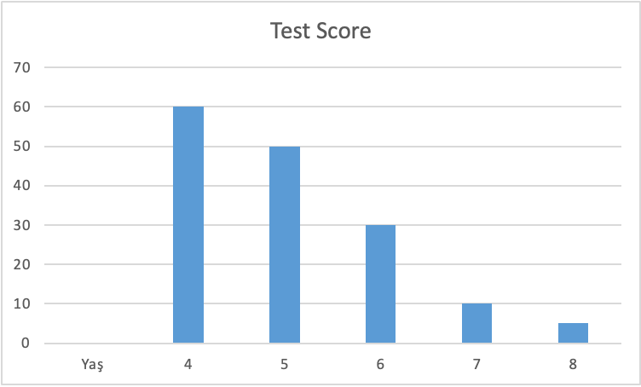

Corresponding Author, Title, Institution (The name of the department will also be written if the institution is a University), e-mail address, ORCID NO.
Title, Institution (The name of the department should also be written if the institution is a University), e-mail address, ORCID NO, (Authors should provide this information in a separate page.)

